**Project: HealthKart(clone)**

By: Adithya Gopakumar

Home page

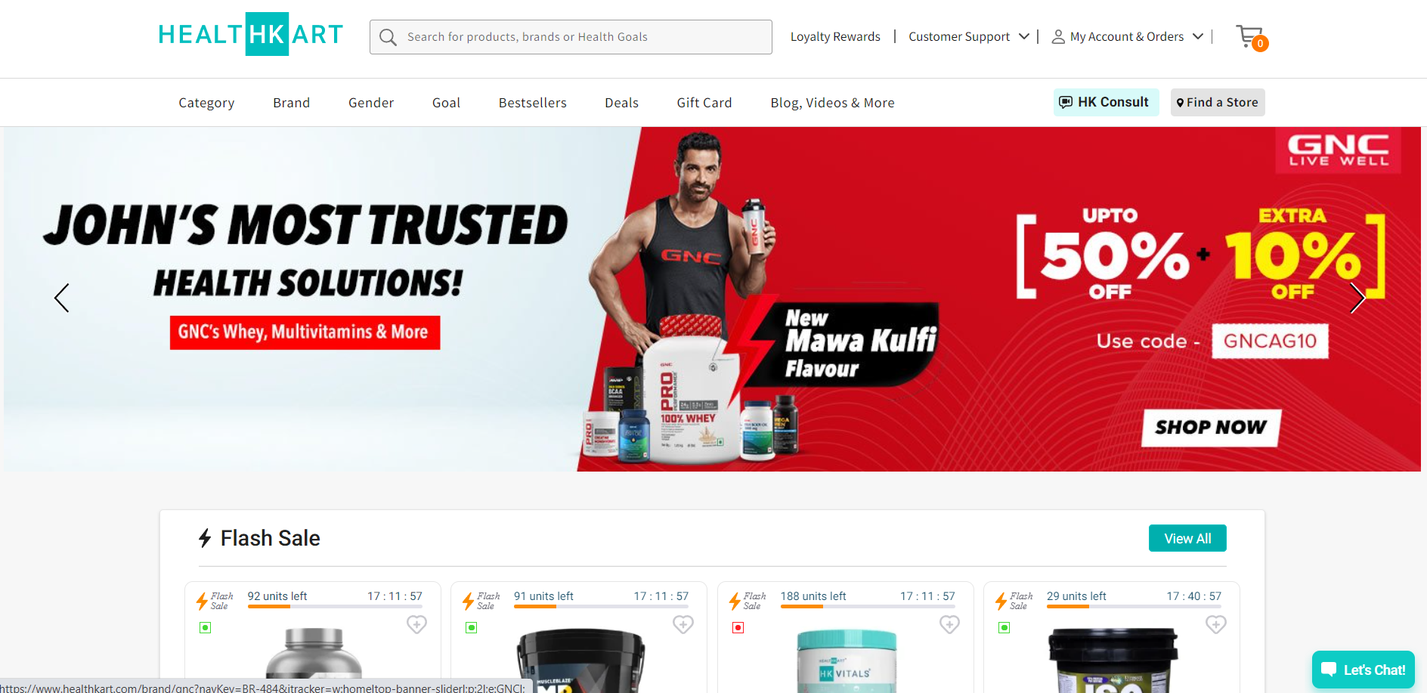

HealthKart is an online health and fitness store for men and women, which offers health products online and health services to help consumers achieve their fitness goals. The company sells authentic health supplements, fitness equipment, weight loss products, protein supplements, sports gear, and wellness products.

HealthKart offers a comprehensive range of high-quality supplements such as proteins, vitamins, minerals, etc., sourced from across the world. These supplements are used for athletic performance, fitness, and wellness. It delivers these health products online through a combination of an online portal and 95+ retail stores. The company also offers assistance to its customers in product selection and diet planning through trained nutritionists.

HealthKart has served over 1.5 mn customers and delivers 80,000+ HealthKart products to 500+ cities in any given month. HealthKart's MuscleBlaze is known as one of India’s largest bodybuilding and sports nutrition supplement brands, whereas its HK Vitals, is the first choice in India in the multivitamins segment. HealthKart India provides a wide range of protein supplements, weight loss products, gym memberships, personal trainers, and many products and services, thereby enabling customers to access all fitness products on one platform.

Listing Page

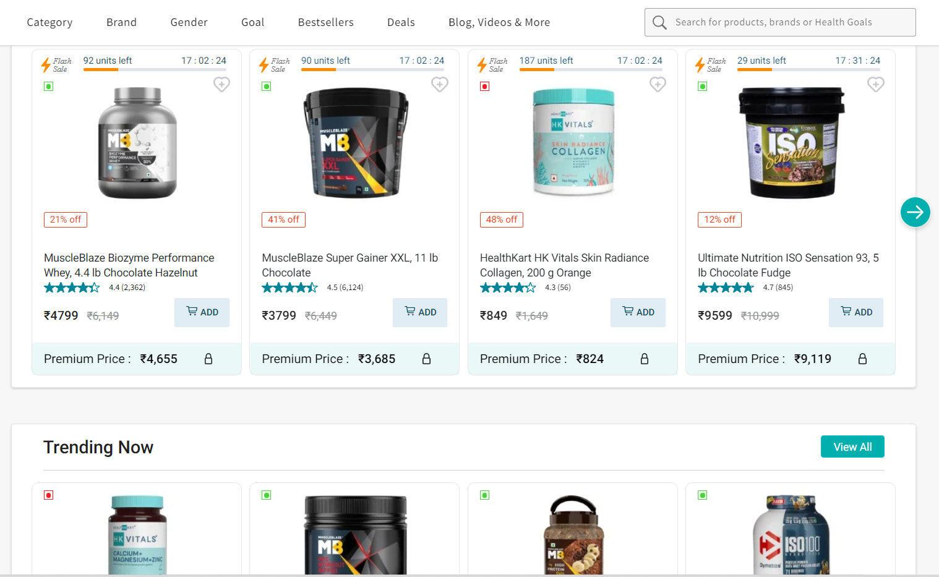

Cart and Payment section

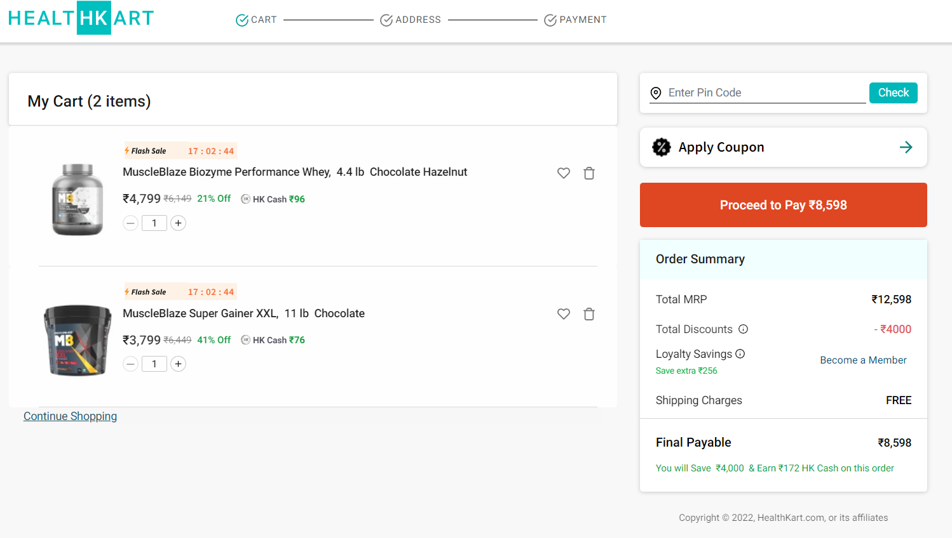

Technologies that will be used during this project :

1. For Front-End :

i) HTML

ii) CSS

iii) Bootstrap

iv) Javascript

v) React

1. For Back-End :

i) Node.js

ii) MongoDB

Features of this project :

i) User login

ii) Add to cart

iii) Buy now

iv) Sticky navigation bar

v) Form fill

vi) Many products in many categories

vii) Home page carousel

viii) and much more